Task

You have been tasked to construct a proposal/specification for a project. The topic of your proposal is up to you (although a default is provided below).

## Your proposal/specification must include at the minimum:

* A high-level description of your project
* A report intended audience and use
* You must include sketches if your project is interactable in digital or physical space.
  + Sketches will imply how a product will look like when it is finished
  + How it is used
  + How it is put together (if applicable)
* Lightweight process diagramming (boxes and arrows) of how the critical parts of your project will work
* Project Story Cards of your project
  + Story Cards should be quoted for Must | Should | Could have
  + You do not have to quote time to complete or complexity

## Project Proposal

You can choose to build any project. However, you are greatly restricted on time and resources. Resources may be able to be acquired, but due to covid/global shortages/etc., this is not dependable. Time is limited, as semester finishes early, and we have 3 hours 40 minutes each week.

Your project must be a small series of mechatronic systems. Each system includes sensors, actuators, physical models, and have some sort of intended interaction. In addition, the system’s intended interaction must be driven by decoupled serial events. These serial events will come from a third party service (raspberry pis). This process will be provided as a library.

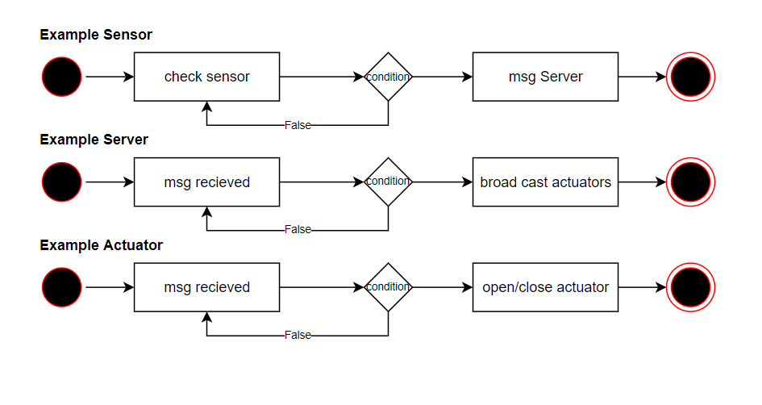

The default example for this project is constructing a part of the Cyber Range City (Arduino City). An example of a feature of Arduino City might be a draw bridge that opens when a “boat” gets too close and closes the road for safety purposes.

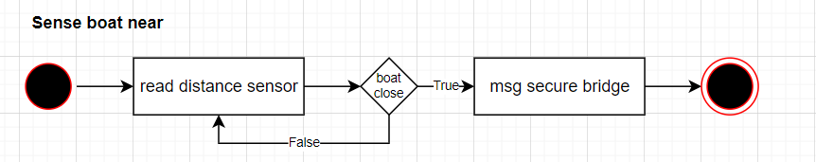

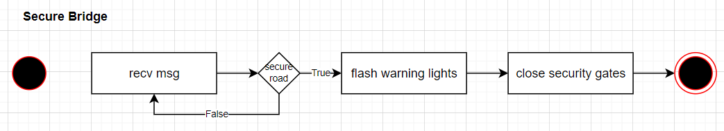

etc

## Submission Guide

### Learning tasks

At the minimum:

* A specification document
* Feel free to add anything else you want

### Learning deliverables

* A short description of your project.
* A description of the indented audience and use
* Sketches/Process diagramming
* Story Cards